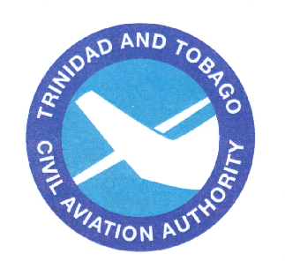  Trinidad and Tobago  Civil Aviation Authority | TTCAA  Advisory  Circular

Subject: COMMERCIAL PILOT LICENCE KNOWLEDGE TESTS
TTCAA Advisory Circular TAC- PEL065

Date: 06/10/02

PURPOSE

1. (1) The purpose of this TTCAA Advisory Circular (TAC) is to provide guidance for applicants preparing to take Commercial Pilot Knowledge Tests. Appendices provide subject matter outline, reference material, and sample questions, with subject matter knowledge codes.

(2) The Trinidad and Tobago Civil Aviation Regulations (TTCARs) can be obtained from the Trinidad and Tobago Government printery, Victoria Avenue Port-Of-Spain Trinidad. TTCAR No. 1 covers the requirements for personnel licensing.

(3) This TAC can be purchased from the Tobago Civil Aviation Authority, P.O. Box 2163, National Mail Centre, Golden Grove Road, Piarco, Republic of Trinidad and Tobago or downloaded from the TTCAA website at <http://www.caa.gov.tt>.

(4) Comments and/or questions regarding this TAC should be sent to Trinidad and Tobago Civil Aviation Authority, P.O. Box 2163, National Mail Centre, Golden Grove Road, Piarco, Republic of Trinidad and Tobago.

INTRODUCTION

2. (1) What is required to become a skilled and effective commercial pilot? Although some individuals possess more knowledge and skills than others, no one is a natural-born pilot. Competent pilots become so through study, training, and experience.

(2) This knowledge test guide will answer most questions about taking the Commercial Pilot knowledge test by covering the following areas: knowledge test eligibility requirements; knowledge areas on the tests; descriptions of the tests; process for taking a knowledge test; validity of Airman Test Reports; use of test aids and materials; cheating or other unauthorized conduct; retesting procedures; and obtaining training and testing publications and general information.

(3) This guide will help applicants in preparing to take one or all of the following tests:

- Commercial Pilot—Aeroplane;

- Commercial Pilot—Helicopter (in development);

- Commercial Pilot—Glider (in development);

- Commercial Pilot—Aeroplane Validation;

- Commercial Pilot—Aeroplane Conversion;

- Military Competency – Aeroplane;

- Military Competency – Helicopter (in development).

(3) This guide is not offered as an easy way to obtain the necessary information for passing the knowledge tests. Rather, the intent of this guide is to define and narrow the field of study to the required knowledge areas included in the tests.

(4) The Trinidad and Tobago Civil Aviation Authority (TTCAA) airman knowledge tests are a very effective instrument for aviation safety and regulatory compliance. However, these tests can only sample the vast amount of knowledge every pilot needs to operate safely in an ever increasingly complex airspace system.

KNOWLEDGE TEST ELIGIBILITY REQUIREMENTS

3. Individuals pursuing a Commercial Pilot licence should review: Trinidad and Tobago Civil Aviation Authority Regulations 2004, No. 1 General Application and Personnel Licensing Part II Regulation 39 and Regulation 44 for the Conversion of a Commercial Pilot Licence from another contracting state and Regulation 70 for the validation of a foreign licence. The applicant for a Commercial Pilot licence knowledge test must be at least 16 years old and have a TTCAA Class 1 medical certificate.

KNOWLEDGE AREAS ON THE TESTS

4. (1) Commercial Pilot tests are comprehensive because they must test the applicant’s knowledge in many subject areas.

(2) Applicant’s pursuing a Commercial Pilot licence or added rating should review TTCAR Part II Regulation 40 - Knowledge areas, for the knowledge areas on the tests.

DESCRIPTIONS OF THE TESTS

5. (1) All test questions are the objective, multiple-choice type. Each question can be correctly answered by the selection of a single response. Each test question is independent of other questions; therefore, a correct response to one does not depend upon, or influence, the correct response to another. The minimum passing score is 75 percent.

(2) The following tests each contain 100 questions, and applicants are allowed a maximum of 3.0 hours to complete each test.

- Commercial Pilot—Aeroplane;

- Commercial Pilot—Helicopter (in development);

- Commercial Pilot—Glider (in development).

(3) The following tests each contain 50 questions, and applicants are allowed a maximum of 2.0 hours to complete each test.

- Commercial Pilot—Aeroplane Validation;

- Commercial Pilot—Aeroplane Conversion;

- Military Competency—Aeroplane;

- Military Competency —Helicopter (in development).

(4) Communication between individuals through the use of words is a complicated process. In addition to being an exercise in the application and use of aeronautical knowledge, a knowledge test is also an exercise in communication since it involves the use of the written language. Since the tests involve written rather than spoken words, communication between the test writer and the person being tested may become a difficult matter if care is not exercised by both parties. Consequently, considerable effort is expended to write each question in a clear, precise manner. Test applicants should be sure to carefully read the instructions given with each test, as well as the statements in each test item.

(5) When taking a test, keep the following points in mind:

- Answer each question in accordance with the latest regulations and guidance publications;

- Read each question carefully before looking at the possible answers. Test applicants should clearly understand the problem before attempting to solve it;

- After formulating an answer, determine which choice corresponds with that answer. The answer chosen should completely resolve the problem;

- From the answers given, it may appear that there is more than one possible answer; however, there is only one answer that is correct and complete. The other answers are either incomplete, erroneous, or represent common misconceptions;

- If a certain question is difficult, it is best to mark it for review and proceed to the next question. After answering the less difficult questions, return to those marked for review and answer them. The review marking procedure will be explained to test applicants prior to starting the test. Although the computer should alert test applicants to unanswered questions, test applicants should make sure every question has an answer recorded. This procedure will enable test applicants to use the available time to maximum advantage;

- When solving a calculation problem, the answer closest to the applicant’s solution should be selected. The problem has been checked with various types of calculators; therefore, if the problem has been solved correctly, the applicant’s answer will be closer to the correct answer than any of the other choices.

PROCESS FOR TAKING A KNOWLEDGE TEST

6. (1) The first step in the process of taking a knowledge test is to contact the TTCAA office. They can provide applicants with information relating to knowledge test prerequisites, required authorizations and endorsements, and where applicants can appear to take computerized knowledge tests and the appropriate fees involved. In addition applicants might want to visit the TTCAA website at <http://www.caa.gov.tt>.

(2) The second step in the process of taking a knowledge test is for the applicant to receive an endorsement from an authorized instructor or Aviation Training Organization that the applicant has completed the required training and is ready to take the knowledge test.

(3) Acceptable forms of endorsement are:

- A certificate of graduation or a statement of accomplishment certifying the satisfactory completion of the ground school portion of a course for the certificate or rating sought. The certificate or statement may be issued by an approved Aviation Training Organization;

- A written statement or logbook endorsement from an authorized ground or flight instructor certifying that the applicant has completed an applicable ground training or home study course and is prepared to take the knowledge test;

- A failed Airman Test Report, passing Airman Test Report, or expired Airman Test Report (pass or fail), provided that the airman still has the original Airman Test Report in his/her possession;

- An “expired test/credit” letter issued by the TTCAA (in lieu of a duplicate Airman Knowledge Test Report).

(3) The third step in the process of taking a knowledge test is for the applicant to receive written authorization from TTCAA to take the knowledge test.

(4) The fourth step in taking a knowledge test is to proceed to the TTCAA computer knowledge test centre. An applicant for a knowledge test must provide proper identification. Testing centre personnel will not begin the test until the test applicant’s identification is verified.

(5) Upon completion of the knowledge test, each applicant will receive their own Airman Test Report, showing their test score with an embossed seal to authenticate the validity of the document.

(6) The Airman Test Report lists the subject matter areas for questions answered incorrectly. The total number of subject matter knowledge areas shown on the Airman Test Report is not necessarily an indication of the total number of questions answered incorrectly.

(7) The Appendices of this Knowledge Test Guide contains a list of reference materials for applicants to study during their training for the Commercial Pilot licence. The questions on the knowledge test will come from these reference materials. TTCAA Advisory Circular TAC - xxx, Subject Matter Codes for Airman Knowledge Testing, contains subject matter knowledge codes for airman knowledge testing. Applicants should match the subject matter knowledge codes on their Airman Test Report to these codes to review their areas of deficiency.

(8) A list of reference materials has been prepared by TTCAA to establish specific references for all knowledge standards and is to be used when preparing for an airman knowledge test. The list of reference materials is contained in the Appendix to this Knowledge Test Guide. An applicant’s instructor is required to provide instruction on each of the knowledge areas listed on the Airman Test Report and to complete an endorsement of this instruction. The Airman Test Report must be presented to the flight test examiner prior to taking the skill test. During the oral portion of the skill test, the examiner is required to evaluate the noted areas of deficiency.

(9) Applicants requiring a duplicate Airman Test Report due to loss or destruction of the original should send a signed request to the Trinidad and Tobago Civil Aviation Authority, P.O. Box 2163, National Mail Centre, Golden Grove Road, Piarco, Republic of Trinidad and Tobago.

VALIDITY OF AIRMAN TEST REPORTS

7. Airman Test Reports for the Commercial Pilot licence are valid for 24 calendar months. The applicant should plan to complete the skill test during the 24 calendar month validity period. If the Airman Test Report expires before completion of the skill test, the applicant must retake the knowledge test.

USE OF TEST AIDS AND MATERIALS

8. Knowledge test applicants may use aids, reference materials, and test materials within the guidelines listed below. All models of aviation-oriented calculators may be used, including small electronic calculators that perform only arithmetic functions (add, subtract, multiply, and divide). Simple programmable memories, which allow addition to, subtraction from, or retrieval of one number from the memory, are permissible. Also, simple functions, such as square root and percent keys are permissible. The following guidelines apply:

- Applicants may use any reference materials provided with the test. In addition, applicants may use scales, straightedges, protractors, plotters, navigation computers, log sheets, holding pattern entry aids, and electronic or mechanical calculators that are directly related to the test;

(b) Manufacturers permanently inscribed instructions on the front and back of such aids, e.g., formulas, conversions, regulations, signals, weather data, holding pattern diagrams, frequencies, weight and balance formulas, and air traffic control procedures are permissible;

- TTCAA personnel may provide a calculator to applicants and/or deny use of their personal calculator based on the following limitations:

  - Prior to, and upon completion of the test, while in the presence of the proctor, applicants must actuate the ON/OFF switch and perform any other function that ensures erasure of any data stored in memory circuits, including removal of batteries;

  - The use of electronic calculators incorporating permanent or continuous type memory circuits without erasure capability is prohibited. The proctor may refuse the use of the applicant’s calculator when unable to determine the calculator’s erasure capability;

  - Printouts of data must be surrendered at the completion of the test if the calculator incorporates this design feature;

  - The use of magnetic cards, magnetic tapes, modules, computer chips, or any other device upon which pre-written programs or information related to the test can be stored and retrieved is prohibited;

  - Applicants are not permitted to use any booklet or manual containing instructions related to use of test aids.

- Dictionaries are not permitted in the testing area;

- The TTCAA test proctor makes the final determination relating to test materials and personal possessions the applicant may take into the testing area.
CHEATING OR OTHER UNAUTHORIZED CONDUCT

9. Computerized knowledge testing must be carried out in accordance with the strictest security procedures to avoid test compromise. The TTCAA Test Proctor will terminate a test at any time that he/she suspects that a cheating incident has occurred. A TTCAA investigation will then be conducted. If the investigation determines that cheating or unauthorized conduct has occurred, then any airman licence, certificate, or rating that the applicant holds may be revoked, and the applicant will be prohibited for 1 year from applying for or taking any test for a licence, certificate or rating under TTCAR No. 1 Regulation 13.

RETESTING PROCEDURES

10. (1) Applicants who receive a grade lower than 75 percent and who wish to retest must present the following to TTCAA testing centre personnel when appearing for the purpose of retesting:

- A failed Airman Test Report;

- A written endorsement from an authorized instructor certifying that additional instruction has been given, and the instructor finds the applicant competent to pass the test;

- A written authorization from TTCAA to retake the test.

(2) Applicants possessing an Airman Test Report with a score of 75 percent or higher who decide to retake the test in anticipation of a better score, may retake the test after 30 days from the date their last test was taken. The TTCAA will not allow applicants to retake a passed test before the 30-day period has lapsed. Prior to retesting, applicants will be required to surrender their current Airman Test Report to the test proctor. The last test taken will reflect the official final score.

OBTAINING TRAINING AND TESTING PUBLICATIONS AND GENERAL INFORMATION

11. Most of the current TTCAA airman training and testing publications can be obtained in electronic format from TTCAA at the TTCAA website at <http://www.caa.gov.tt>.

AIRMAN KNOWLEDGE TEST ITEMS

12. Sample questions are contained in the appendix to this test guide and are representative of questions for airman knowledge tests and their corresponding subject matter knowledge codes. These will help airmen become familiar with similar questions on the airman knowledge tests. The knowledge test is not designed to intimidate any prospective airman; it is designed to measure the level of competency required to receive a TTCAA licence. The list of reference materials contained in the appendix to this test guide is provided to ensure that instructors and students are able to determine the importance of the subject matter to be taught and learned

COMPUTER TESTING SUPPLEMENTS

13. The computer testing supplements contain the graphics, legends, and maps that are needed to successfully respond to certain knowledge test items. These supplements will be provided by TTCAA test centre personnel during the airman knowledge test.

KNOWLEDGE TEST GUIDES

14. The knowledge test guides describe the knowledge testing policy and procedures for each licence area.

OTHER COMPUTER TESTING INFORMATION

15. Other computer testing information provides specific test information, such as test name, test code (three-digit test identifiers), number of questions, and the time (hours) allotted for each knowledge test. The test identifiers will assist airmen in selecting the proper test for the licence/rating being sought.

SKILL TEST STANDARDS

16. The skill test standards outline the knowledge and skill requirements for each airman licence and rating. The references listed in each task of the skill test standards indicate the specific publications used to develop the skill standards. The ability to issue immediate changes prior to publishing revised printed copies ensures the skill test standards are always accurate and usable.

SUBJECT MATTER REFERENCE/KNOWLEDGE CODES

17. The appendices of this guide contain the listings of reference materials and sample test questions with related subject matter knowledge codes used for airman knowledge testing. The listings of reference materials and subject matter knowledge codes have been prepared by the Trinidad and Tobago Civil Aviation Authority (TTCAA) to establish specific references for all knowledge standards. The listings contain reference materials to be used when preparing for all airman knowledge tests. The subject matter knowledge codes contained in TTCAA Advisory Circular TAC - xxx, should be referred to when reviewing areas of deficiency on airman knowledge test reports.

__________________________________________
Ramesh Lutchmedial
Director General of Civil Aviation

THIS PAGE INTENTIONALLY LEFT BLANK

Appendix A

commercial pilot – Aeroplane (cax)

Subject Matter Outline
The following outlines the major topics and underlying content areas on the Commercial Pilot – Aeroplane knowledge test.

- Air Law:

  - Rules and regulations relevant to the holder of a CPL;
  - Rules of the air;
  - Appropriate air traffic services practices and procedures.

- Aircraft General Knowledge:

  - Principles of operation and functioning of powerplants, systems and instruments;
  - Operating limitations of the appropriate category of aerocraft and powerplants;
  - Relevant operational information from the flight manual or other appropriate document;
  - Use and serviceability checks of equipment and systems of appropriate aircraft;
  - Maintenance procedures for airframes, systems and powerplants of appropriate aircraft.

- Flight Performance and Planning:

- Effects of loading and weight distribution on aircraft handling, flight characteristics and performance;
- Weight and balance calculations;
- Use and practical application of take-off or launching, landing and other performance data;
- Pre-flight and en-route flight planning appropriate to operations under VFR;
- Preparation and filing of air traffic services flight plans;
- Appropriate air traffic services procedures, position reporting procedures, altimeter setting procedures, and operations in areas of high-density traffic;
- In the case of helicopter and powered-lift, effects of external loading.

- Human Performance:

- Human performance relevant to the appropriate aircraft type;
- Principles of threat and error management.

- Meteorology:

- Interpretation and application of aeronautical meteorological reports, charts and forecasts;
- Use of, and procedures for obtaining, meteorological information, pre-flight, and in-flight;
- Altimetry;

Appendix A

commercial pilot – Aeroplane (cax)

SUBJECT MATTER OUTLINE

- Aeronautical meteorology;
- Climatology of relevant areas in respect of the elements having an effect upon aviation;
- The movement of pressure systems, the structure of fronts, and the origin and characteristics of significant weather phenomena which affect take-off, en-route and landing conditions;
- Causes, recognition and effects of icing; frontal zone penetration procedures.
- Hazardous weather avoidance.

- Navigation:

- Air navigation, including the use of aeronautical charts, instruments and navigation aids;
- Understanding of the principles and characteristics of appropriate navigation systems.
- Operation of air borne equipment.

- Operational Procedures:

- Application of threat and a error management to operational procedures;
- Use of aeronautical documentation such as AIP, NOTAM, aeronautical codes and abbreviations;
- Altimeter setting procedures;
- Appropriate precautionary and emergency procedures;
- Operational procedures for carriage of freight;
- Potential hazards associated with dangerous goods;
- Requirements and practices for safety briefing to passengers, including precautions to be observed when embarking and disembarking from aircraft;
- In the case of the helicopter, and if applicable powered-lift, settling with power, ground resonance, retreating blade stall, dynamic roll-over and other operational hazards;
- Safety procedures, associated with flight under VFR.

- Principles of Flight:

- Principles of flight relating to the appropriate category of aircraft.

- Radiotelephony:

- Communication procedures and phraseology as applied to VFR operations;
- Action to be taken in case of communication failure.

Appendix A

Commercial Pilot—Aeroplane (cAx)

SAMPLE TEST QUESTIONS AND ANSWERS

1. Drinking only 30ml (one ounce) of alcohol impairs oxygen absorption to the brain and equates to being at

A—5,000 feet pressure altitude.
B—2,000 feet pressure altitude.
C—1,000 feet pressure altitude.

Answer B--Subject Matter Code: K29

2. If the aeroplane attitude initially tends to return to its original position after the elevator control is pressed forward and released, the aeroplane displays

A—positive dynamic stability.
B—positive static stability.
C—neutral dynamic stability.

Answer B--Subject Matter Code: R06

3. What information is provided by the Radar Summary Chart that is not shown on other weather charts?

A—Lines and cells of hazardous thunderstorms.
B—Ceilings and precipitation between reporting stations.
C—Areas of cloud cover and icing levels within the clouds.

Answer A--Subject Matter Code: M42

4. What is the meaning of the terms PROB40 2102 +TSRA as used in Terminal Aerodrome Forecasts (TAF)

A—Probability of heavy thunderstorms with rain showers below 4,000 feet at time 2102.
B—Between 2100Z and 0200Z there is a forty percent (40%) probability of thunderstorms with heavy rain.
C—Beginning at 2102Z forty percent (40%) probability of heavy thunderstorms and rain showers.

Answer B--Subject Matter Code: M13

Appendix A

commercial pilot – Aeroplane (cax)

SAMPLE TEST QUESTIONS AND ANSWERS

5. GIVEN:
True Course 345º
True heading 355º
True airspeed 85 kts
Groundspeed 95 kts
Determine the wind direction and speed.

A—095º and 19 knots.
B—113º and 19 knots.
C—238º and 18 knots.

Answer B--Subject Matter Code: H23

6. (*Refer to figure 52, point 4) The terrain at the obstruction approximately 8 NM east southeast of the Lincoln Airport is approximately how much higher than the aerodrome elevation?

A—376 feet.
B—835 feet.
C—1,135 feet.

Answer B--Subject Matter Code: N34

7. GIVEN:
Wingtip bearing change 15 º
Elapsed time between bearing change 6 min
Rate of fuel consumption 8.6 gal/hr
Calculate the approximate fuel required to fly to the station.

A—3.44 gallons.
B—6.88 gallons.
C—17.84 gallons.

Answer A--Subject Matter Code: N11

8. Except when necessary for takeoff or landing, what is the minimum safe altitude for a pilot to operate an aircraft anywhere?

A—An altitude allowing, if a power unit fails, an emergency landing without undue hazard to persons or property on the surface.
B—An altitude of 500 feet above the surface and no closer than 500 feet to any person, vessel, vehicle, or structure.
C—An altitude of 500 feet above the highest obstacle within a horizontal radius of 1,000 feet.

Answer A--Subject Matter Code: B24

Appendix A

commercial pilot – Aeroplane (cax)

SAMPLE TEST QUESTIONS AND ANSWERS

9. A Class 2 Medical Certificate was issued to a 19-year-old pilot on August 10, this year. To exercise the privileges of a Commercial Pilot licence, the medical certificate will expire at midnight on

A—August 10, 1 year later.
B—August 31, 2 years later.
C—August 31, 1 year later.

Answer A--Subject Matter Code: B111

10. To establish a climb after takeoff in an aircraft equipped with a constant-speed propeller, the output of the engine is reduced to climb power by decreasing manifold pressure and

A—increasing RPM by decreasing propeller blade angle.
B—decreasing RPM by decreasing propeller blade angle.
C—decreasing RPM by increasing propeller blade angle.

Answer C--Subject Matter Code: C45

11. (*Refer to figure 8.)
GIVEN:
Fuel quantity 65 gal
Best power (level flight) 55 percent
Approximately how much flight time would be available with a day VFR fuel reserve remaining?

A—4 hours 17 minutes.
B—4 hours 30 minutes.
C—5 hours 4 minutes.

Answer B--Subject Matter Code: C04

12. What are the clearance from clouds and visibility requirements for a VFR aircraft operating at FL85 in Class E airspace?

A—Clear of clouds and 8km visibility.
B—1500m horizontal and 300m vertical clearance from clouds and 8km visibility.
C—1500 horizontal and 300m vertical clearance from clouds and 5km visibility.

Answer C--Subject Matter Code: P117

Appendix A

commercial pilot – Aeroplane (cax)
Commercial pilot – AEROPLANE VALIDATION (CVL)
commercial PILOT – AEROPLANE CONVERSION (Ccl)

LIST OF REFERENCE MATERIALS

The publications listed below contain study material applicants need to be familiar with when preparing for Commercial Pilot knowledge tests. Most of these publications can be purchased from Trinidad and Tobago Civil Aviation Authority, P.O. Box 2163, National Mail Centre, Golden Grove Road, Piarco, Republic of Trinidad and Tobago or be downloaded from the TTCAA web site at http://www.caa.gov.tt. ICAO publications can be purchased from ICAO at: http://www.icao.int. The latest revision of the listed references should be requested.

(1) Trinidad and Tobago Civil Aviation Regulations (TTCAR) in particular:

(a) TTCAR No. 1 - General Application and Personnel Licensing Regulations

(b) TTCAR No. 2 – Operations Regulations

(c) TTCAR No. 5 – Airworthiness Regulations

(d) TTCAR No. 7 – Instruments and Equipment Regulations

(2) ICAO Annexes: 3, 10 Volume II, 11 and 14 (pertinent parts)

(3) ICAO Document 4444: General provisions, Aero Control service, Approach control service, Aerodrome control service, and Flight information and alerting service.

(4) Aeronautical Information Publication (AIP) Eastern Caribbean

(5) Sectional Aeronautical Chart

(6) Airport/Facility Directory

(7) FAA-H-8083-25—Pilot’s Handbook of Aeronautical Knowledge (adopted in cooperation with FAA)

(8) FAA-H-8083-3—Airplane Flying Handbook (adopted in cooperation with FAA)

(9) FAA-H-8083-1—Aircraft Weight and Balance (adopted in cooperation with FAA)

(10) FAA-H-8083-23—Seaplane (adopted in cooperation with FAA)

Appendix B

Commercial pilot – AEROPLANE VALIDATION (CVL)
commercial PILOT – AEROPLANE CONVERSION (Ccl)

Subject Matter Outline

The following outlines the major topics and underlying content areas on the Commercial Pilot – Aeroplane Validation, and Conversion, knowledge tests.

- Air Law:

(a) Rules and regulations relevant to the holder of a CPL;
(b) Rules of the air;
(c) Appropriate air traffic services practices and procedures.

- Meteorology:

(a) Interpretation and application of aeronautical meteorological reports, charts and forecasts;
(b) Use of, and procedures for obtaining, meteorological information, pre-flight, and in-flight;
- Altimetry;
- Aeronautical meteorology;
- Climatology of relevant areas in respect of the elements having an effect upon aviation;
- The movement of pressure systems, the structure of fronts, and the origin and characteristics of significant weather phenomena which affect take-off, en-route and landing conditions;
- Causes, recognition and effects of icing; frontal zone penetration procedures.
- Hazardous weather avoidance.

- Operational Procedures:

(a) Application of threat and an error management to operational procedures;
(b) Use of aeronautical documentation such as AIP, NOTAM, aeronautical codes and abbreviations;
(c) Altimeter setting procedures;
(d) Appropriate precautionary and emergency procedures;
(e) Operational procedures for carriage of freight;
(f) Potential hazards associated with dangerous goods;
(g) Requirements and practices for safety briefing to passengers, including precautions to be observed when embarking and disembarking from aircraft;
(h) In the case of the helicopter, and if applicable powered-lift, settling with power, ground resonance, retreating blade stall, dynamic roll-over and other operational hazards;
(i) Safety procedures, associated with flight under VFR.

- Radiotelephony:

(a) Communication procedures and phraseology as applied to VFR operations;
(b) Action to be taken in case of communication failure.
Appendix B

Commercial pilot – AEROPLANE VALIDATION (CVL)
commercial PILOT – AEROPLANE CONVERSION (Ccl)

SAMPLE TEST QUESTIONS AND ANSWERS

1. A Class 2 Medical Certificate was issued to a 19-year-old pilot on August 10, this year. To exercise the privileges of a Commercial Pilot licence, the medical certificate will expire at midnight on

A—August 10, 1 year later.
B—August 31, 2 years later.
C—August 31, 1 year later.

Answer A--Subject Matter Code: B111

2. What is the meaning of the terms PROB40 2102 +TSRA as used in Terminal Aerodrome Forecasts (TAF)

A—Probability of heavy thunderstorms with rain showers below 4,000 feet at time 2102.
B—Between 2100Z and 0200Z there is a forty percent (40%) probability of thunderstorms with heavy rain.
C—Beginning at 2102Z forty percent (40%) probability of heavy thunderstorms and rain showers.

Answer B--Subject Matter Code: M13

3. What are the clearance from clouds and visibility requirements for a VFR aircraft operating at FL85 in Class E airspace?

A—Clear of clouds and 8km visibility.
B—1500m horizontal and 300m vertical clearance from clouds and 8km visibility.
C—1500 horizontal and 300m vertical clearance from clouds and 5km visibility.

Answer C--Subject Matter Code: P117

4. If faced with an emergency where Air Traffic Control (ATC) assistance is desired and not already in contact, which frequency can be used to establish communications?

A—121.5 MHz.
B—122.5 MHz.
C—128.725 MHz.

Answer A—Subject Matter Knowledge Code: T01.

Appendix C

Commercial Pilot – helicopter (crh)

(BEING developeD)

THIS PAGE INTENTIONALLY LEFT BLANK

Appendix D

Commercial Pilot – Glider (ceg)

(BEING developeD)

Appendix D
Figures for sample questions

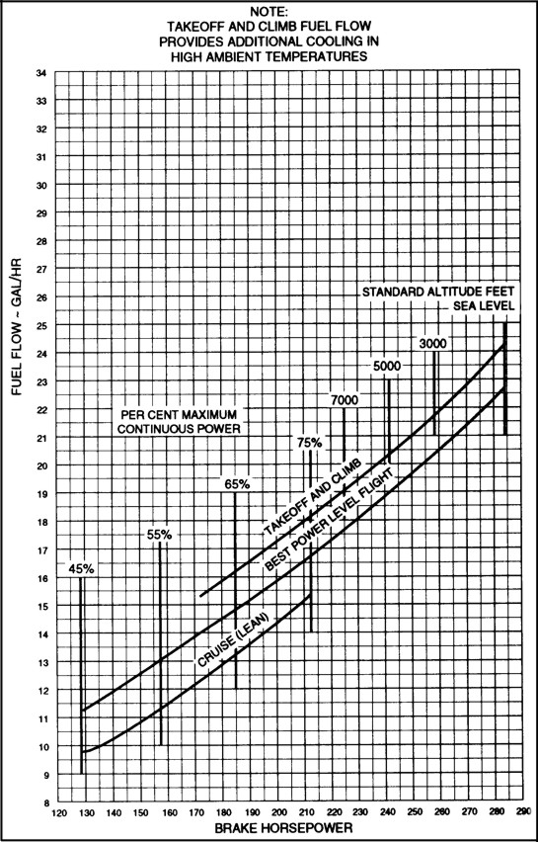

Figure 8.
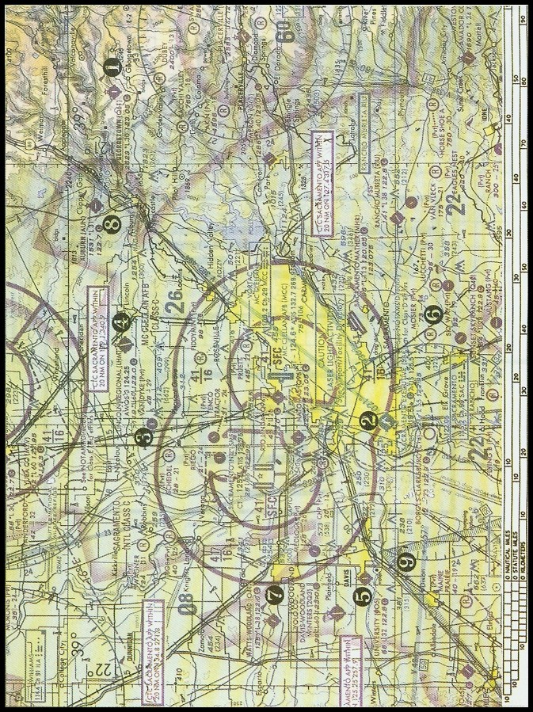

Figure 52.

See Appendix 5 for figures.

