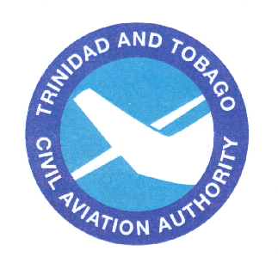  Trinidad and Tobago  Civil Aviation Authority | TTCAA  Advisory  Circular

Subject: TEST AIDS AND MATERIALS THAT MAY BE USED BY APPLICANTS FOR KNOWLEDGE TESTS
TTCAA Advisory Circular TAC-PEL052
Date: 06/10/02

PURPOSE

1. (1) The purpose of this TTCAA Advisory Circular (TAC) is to provide guidance for applicants preparing to take airman knowledge tests. This TAC provides guidance concerning test aids and materials that may be used by applicants when taking knowledge tests required for the licences and ratings.

(2) Trinidad and Tobago Civil Aviation Regulations (TTCARs) have been revised and were published on 24 March 2004. These regulations have been published in 12 parts and can be obtained from the Trinidad and Tobago Government Printery, Victoria Avenue, Port of Spain, Trinidad.

(3) TTCAR No.1, Part II and Part III cover the requirements for personnel licensing.

DISCUSSION

2. (1) Knowledge tests prescribed by the TTCAA under TTCARs, Part II and Part III contain questions that require applicants to analyse the relationship between variables needed to solve aviation problems, in addition to testing for accuracy of a mathematical calculation. The intent is that all applicants are tested on concepts rather than rote calculation ability.

(2) It is permissible to use certain calculating devices when taking knowledge tests, provided they are used within the guidelines of this TAC. The term "calculating devices'' is interchangeable with such items as calculators, computers, or any similar devices designed for aviation-related activities.

GUIDELINES FOR USE OF TEST AIDS AND MATERIALS

3. The applicant may use test aids and materials within the guidelines listed below, if actual test questions or answers are not revealed.

Applicants may use test aids, such as scales, straightedges, protractors, plotters, navigation computers, log sheets, and all models of aviation-oriented calculating devices that are directly related to the test. In addition, applicants may use any test materials provided with the test.

Manufacturer's permanently inscribed instructions on the front and back of such aids, formulas, conversions, regulations, signals, weather data, holding pattern diagrams, frequencies, mass and balance formulas, and air traffic service procedures are permissible.

The test examiner may deny applicants use of their personal calculating devices if the device does not have a screen that indicates all memory has been erased. The test examiner must be able to determine the calculating device's erasure capability. The use of calculating devices incorporating permanent or continuous type memory circuits without erasure capability is prohibited.

The use of magnetic cards, magnetic tapes, modules, computer chips, or any other device upon which pre-written programs or information related to the test can be stored and retrieved are prohibited. Printouts of data will be surrendered at the completion of the test if the calculating device used incorporates this design feature.

The use of any booklet or manual containing instructions related to the use of the applicant's calculating device is not permitted.

Dictionaries are not allowed in the testing area.

The test examiner makes the final determination relating to test materials and personal possessions that the applicant may take into the testing area.

__________________________________________
Ramesh Lutchmedial
Director General of Civil Aviation

